
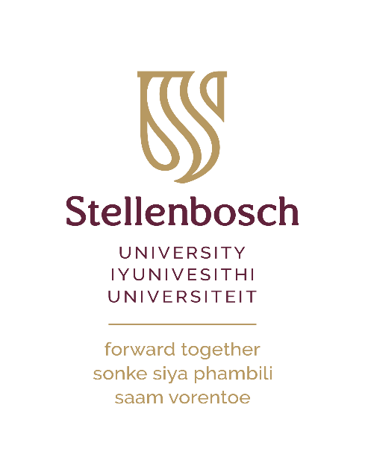

ORIENTATION

PROGRAMME

6-10 February
2023
AVReQ
Centre for the Study of the Afterlife of Violence and the Reparative Quest
DAY ONE: 6 FEBRUARY 2023
Time | Session | Venue | Presenter/ Facilitator
9:00-9:30 | Meeting and Greeting  - Welcome Tea/Coffee  - Distribution of Welcome Pack  - Orientation Programme details | AVReQ Foyer | Jolene Pietersen  Westley Ceasar  Anell Stacey Daries
9:30- 10:00 | Access to AVReQ:  - Allocation of workspaces and computers | AVReQ  Seminar Room | Prof Pumla Gobodo- Madikizela  Jolene Pietersen
10:00-11:30 | The Ground We Stand On:  Visual Redress Tour  Confronting the Legacies and Unpacking SU’s Layers of History. | Meet at AVReQ Entrance | Anell Stacey Daries  Wilhelm Verwoerd
11:30-12:30 | Refreshments | AVReQ Foyer | Jolene Pietersen
12:30-14:00 | Visual Redress Reflections | AVReQ  Seminar Room | Prof Aslam Fataar  Dr Leslie van Rooi
14:15-15:30 | Get to Know Your AVReQ Community  Introduction of AVReQ Staff, Researchers | AVReQ  Seminar Room | Dr Samantha van Schalkwyk

DAY TWO: 7 FEBRUARY 2023
Time | Session | Venue | Presenter/ Facilitator
8:00-8:30 | Arrival and Refreshments | AVReQ Foyer | Jolene Pietersen
8:30-10:30 | Formulating Our Working Agreement **  Beginning to formulate our Working Agreement: | AVReQ  Seminar Room | Ayanda Nyoka  Wilhelm Verwoerd
 | **In this session we formulate, together, the guidelines, commitments and values that will support the cultivation of our supportive learning community during this week and the rest of the year.
10:30-11:00 | Refreshments | AVReQ Foyer | Jolene Pietersen
11:00-13:30 | Generations Past, Present & Future **  In our families and SU | AVReQ  Seminar Room | Ayanda Nyoka  Wilhelm Verwoerd
 | **In this session, we introduce ourselves, SU and AVReQ further through intergenerational family pictures and stories. Everyone is invited to bring a picture of the oldest and of the youngest members of our extended families with whom we had/have some connection. We will then weave these intergenerational stories into an embodied engagement with especially the first sentence of the SU Restitution Statement: “SU acknowledges its inextricable connection with generations past, present and future.”
13:45-15:00 | AVReQ Community Lunch | The Wine Glass Restaurant,  13 Ryneveld Street | Anell Stacey Daries
15:00-16:00 | Student Cards Process | Admin A @ IT Hub | Anell Stacey Daries

DAY THREE: 8 FEBRUARY 2023
Time | Session | Venue | Presenter/ Facilitator
9:00-9:30 | Arrival and refreshments | AVReQ Foyer | Jolene Pietersen
9:30- 10:30 | Overview of Centre  Vision, Mission, Postgraduate and postdoc fellows | AVReQ  Seminar Room | Prof Pumla Gobodo-Madikizela
10:30-12:30 | AVReQ Community Scholarship:  Sharing of Staff, Students, and Postdocs Research Projects—An Introductory Conversation | AVReQ  Seminar Room | Dr Samantha van Schalkwyk
12:30-14:00 | AVReQ Community Lunch | Taste  44 Ryneveld Street | Jolene Pietersen  Lireko Qhobela
14:15-15:30 | Access to AVReQ Network:  IT Support Session  access to Printer | AVReQ  Seminar Room | Jolene Pietersen

DAY FOUR: 9 FEBRUARY 2023
Time | Session | Venue | Presenter/ Facilitator
8:30-9:00 | Guide Tour of Stellenbosch University Library | Stellenbosch University Library | Marlene Hendriksz
9:00-9:30 | Post-graduate Office Support Services:  Information session | Stellenbosch University Library: E-classroom #4659 | Cristen Macloed
9:30-10:00 | Graduate School Support Services:  Information session | Stellenbosch University Library: E-classroom #4659 | Dr Candice Steele
10:00-12:00 | Postgraduate Support Services:  Library Training | Stellenbosch University Library: E-classroom #4659 | Marlene Hendriksz
12:30-13:30 | Public Lecture: Prof Anthony Collins  “The Sound of Children Screaming Has Been Removed”: Conundrums of Silence and Violence | AVReQ  Seminar Room | Prof Pumla Gobodo-Madikizela
13:30-14:00 | Post-Lecture  Refreshments | AVReQ  Seminar Room | Jolene Pietersen
14:30-16:00 | Stellenbosch University Museum Tour | Stellenbosch University Museum | Rabia Abba Omar  Wilhelm Verwoerd
16:30-18:00 | Drinks | De Warenmarkt,  20 Ryneveld Street | Lireko Qhobela  Jolene Pietersen

DAY FIVE: 10 FEBRUARY 2023
Time | Session | Venue | Presenter/ Facilitator
9:00- 10:30 | Debrief & Reflections:  Orientation Week, Expectations | AVReQ  Seminar Room | Gratia Ilibigiza  Ayanda Nyoka
10:30-11:30 | MoU Information Session | AVReQ  Seminar Room | Dr Samantha van Schalkwyk
11:30-12:30 | Training: AVReQ Audio-Visual Equipment  Conferencing/Seminars | AVReQ  Seminar Room | Westley Ceasar
12:30-14:00 | AVReQ Community Lunch | Oude Werf,  30 Church Street | Lireko Qhobela

